Itinerary
Friday 6th of September
Arrival at Bigbury Camping Barn from 5 pm
Address:
Postcode: TQ7 4AP

Please use the What three words App with the words: Snow-Insulated-Tablet
You can download the app using the link below:
Download the free what3words app | what3words
Parking is available but where possible please lift share.

Friday 6 pm:

Welcome circle; this is your time to settle in, make yourself at home and enjoy the outdoor spa facilities including; A Wood Fired Hot tub, Sauna and Plunge pool. Mount Folly camping barn is not quite self-catering and not quite glamping, a simplistic place to stay with no fuss allowing us to appreciate the gifts of nature. It's set in the beautiful South Devon countryside, with views down the valley to Challaborough Bay. You will be in walking distance of Bigbury Beach, providing an exhilarating walk to the beach and waking up to the sound of the waves. We are confident that you will fall in love with this little home-from-home hideaway.
With its eco-friendly outdoor spa facilities which you can enjoy at your leisure, throughout the weekend, bringing both physical and mental wellness benefits, for aiding your recovery post-surf and yoga sessions. Cold water therapy and Saunas have been shown to support recovery and reduce inflammation, helping soothe sore muscles.
The camping barn is a converted traditional barn and therefore has a unique layout.
There are three Bedrooms, the first room has 6x Single Camp beds with two comfy sofas to make yourself at home.
(Please see picture below)

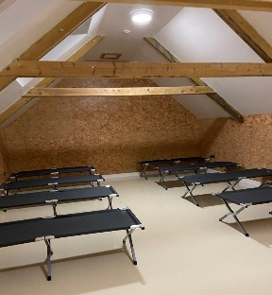

Bedroom two has three single beds and two doubles.
(See Picture below)
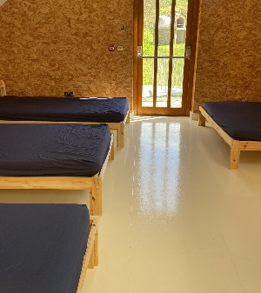

and bedroom three has one double and one single bunk bed.
(See Picture below.)
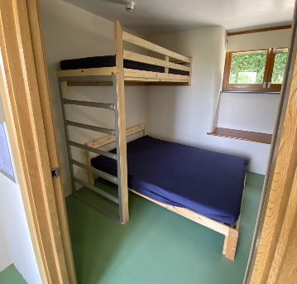
The camping barn is equipped with showers, toilets and a small kitchen.
19:30 Dinner
Gathering around a large table with our retreat family for the weekend, you will be served a classic, Chilli and Jacket potatoes (fully vegan) with fresh salad and homemade bread.
Please do let us know if you have any dietary requirements upon booking.
21:00 Bedtime Yoga
Becky will guide you through a Bedtime yoga wind-down routine, to calm your nervous system, and release tension from the body making it easier to relax, unwind and prepare the body for sleep. Many people find that doing yoga before bed helps them fall asleep faster and promotes deeper, more restful sleep, allowing you to wake up fully refreshed and ready for a day of surf and adventures.
Saturday 7th
7 am Sunrise Yoga:
We will start our day by gently stretching out the body and working on various muscle groups at the same time to build strength and flexibility throughout. When we practice yoga in the morning it can boost our energy levels, helping us feel more awake and alert before we take a little stroll down to the beach.

8:15 am: Walk to Beach
8:45 am: Coffee and Breakfast on the Beach
Enjoy locally roasted Beach Barista coffee sitting on the beach, soaking up the sun’s rays and enjoying a mindful moment sipping our coffee next to the waves with a homemade granola bar filled with protein and nuts to fuel you for your second yoga session.
9:30 am: Beach Surfers Yoga
We will work through a mobility routine, preparing both mentally and physically for our day of surfing. We will warm up key muscles, for example our shoulders, hips and core to support us in balancing, popping up and paddling all day on the waves! Take the time not only to warm up your body but your brain too, practising meditation and mindfulness techniques to relieve any pre-surf jitters so that you can head out with a clear head feeling focused and ready to enjoy your time in the water.
11 am Surf Sesh (Filmed)
During this session, whether you have already started your surfing journey or just embarking on it, we have you covered. With our two highly experienced local surf instructors, you will be given the appropriate challenges based on your pre-course aims. To help you achieve this, there will be video analysis, giving opportunities to work with a surf instructor away from the water. We believe having visual feedback that you can review is the best way to improve and celebrate your progress. At the end of the weekend, your surf instructor will give you some exercises to continue the journey at home if you can’t get to the sea.
13:00 - Lunch at Outside
It’s time to refuel, we'll head for a delicious, healthy meal at Outside that will nourish your body and satisfy your taste buds. You will be greeted at the table with your very special goodie bags, filled with wonderful treats and have our lunch.
15:00 - Yoga at the Barn
Heading back to our little home, stretching out our body after a busy fun-filled day helping the body recover, and reducing muscle soreness and stiffness. This will be a super chilled-out practice on our backs or seated, so you can enjoy a calming and meditative practice that promotes relaxation and recovery.
16:00 - Use facilities/ Independent feedback on Surfing and Yoga practice.
For those who want video evidence of them standing up and having the time of their life, this is the perfect opportunity to see the stoke. For those who want a technical breakdown of their performance, whether it be catching green waves, take off, turning or more radical manoeuvrers such as cut back, floaters etc… this is the perfect time to evaluate what you need to work and how to go about getting to the next level.
18:00 – Indulge your senses with a delicious artisan hand-made pizza:
Pizza will be cooked in a wood-fired oven, just a mile away from the camping barn. This is at an extra cost from the retreat, but Jess and I will be supplying sides. Preordering will be required, therefor we will be taking orders on Friday night.
Menus | Bigbury Bay Pizzas

20:00 - Movie Night
Sit back, relax and enjoy a classic surf movie under the stars… This will be outside weather permitting.
22:00 - Bedtime breathwork
Deep breathing techniques can calm the mind and prepare the body for sleep. It helps falling faster and experiencing deeper, more restful sleep cycles.

Sunday 8th
8:30: Rise and Shine
We thought you would like that lie-in! We will provide an energising breakfast, including fruit, yoghurt and granola to fill your boots before another day of action. Coffees and teas will be available and time to pack our bags ready for check out and a fun-filled day on the beach.
9:30: Beach Yoga
Becky will guide you through a dynamic flow that will improve your strength, flexibility, and balance. The session will be suitable for all abilities and practising all this on the beach allows you to connect with the natural elements of the sand, sea and sun. There are so many benefits to being so close to being out in nature, especially close to the sea. When we are next to the ocean the air contains higher levels of negative ions and these are thought to have a positive effect on mood.
11:00: Supervised Surf Practice (Hire Included)
This is the perfect opportunity to put all that feedback into practice, consolidate some of the previous day's learnings and refine some of your new surfing skills.
13:00: Good-Bye Circle
​We will have a little huddle around the beach, maybe a cold water dip and say our goodbyes X
What to bring:
- Swim attire – (more than one if possible.)
- Towel,
- Yoga mat,
- Cash for Pizza,
- Sleeping bags/ duvets and pillows,
- Toiletries,
- Warm clothes,
- Appropriate bedtime wear,
- Suncream,
- Snacks,
- Water bottles,
- Yoga Wear,
- Medication / personal essential items needed,
- Where possible coffee keep cups.
- Provided: Wetsuits and surfboards (if you want to use your own that’s fine!)

